Predicting Employee Retention

**Problem statement** – Identify the factors to improve the employee retention in the organization and increase the turn around.

**Objectives** – Help HR team to identify the factors that they work on to improve the employee retention.

**Approach** –

* Perform EDA to identify the gaps in the data set
* Rectify the gaps by removing the null data, removing redundant columns, removing duplicate information.
* Find out the outlier and its impact to the analysis
* Convert categorial data to the numeric values
* Scale all data for better analysis
* Remove high corelated features as they might give incorrect result
* Use Recursive Feature Elimination techniques for finding the suitable features for model preparation
* Check the different measuring technique such as Confusion matrix, Accuracy, Specificity, Recall, Precision for model performance
* Use ROC curve to identify the nearest possible correct probability value for prediction

Charts –

* **ROC Curve**

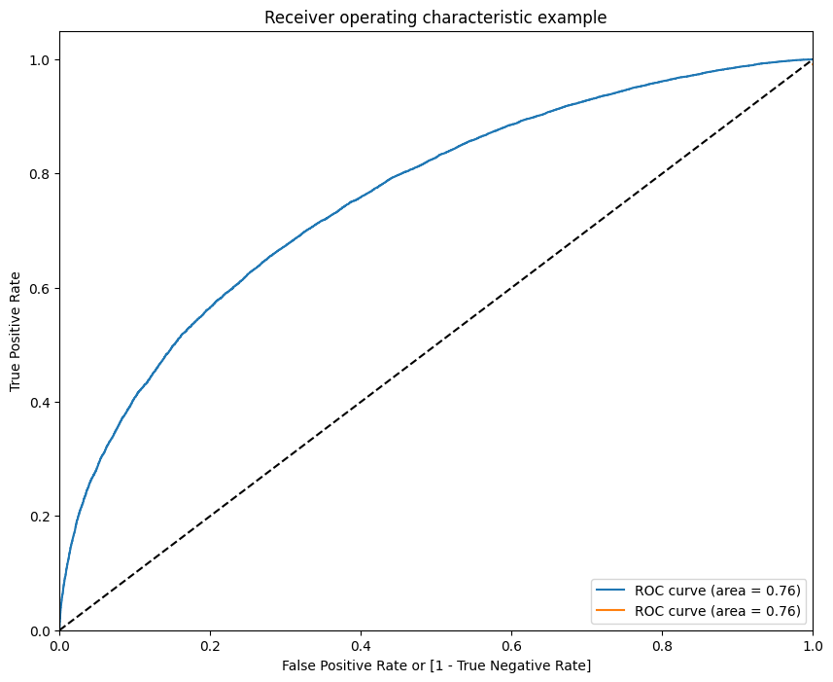

* **accuracy, sensitivity, and specificity at different values of probability cutoffs**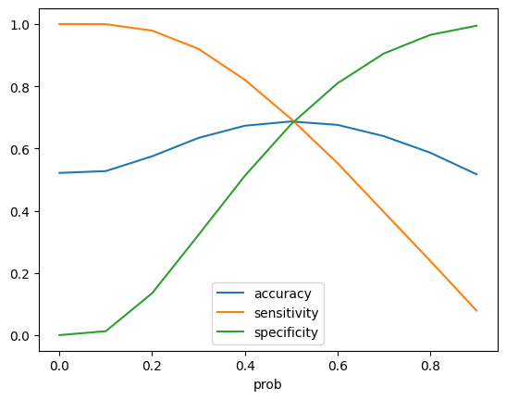

**Model Matrix –**

* Accuracy - 0.6867567348919991
* True Positive - 17911
* True Negative - 16045
* False Positive - 7618
* False Negative - 7870
* Sensitivity - 0.694736433807843
* Specificity - 0.6780627984617336
* Precision - 0.7015942653452936
* Recall - 0.694736433807843

**Precision-Recall trade off –**

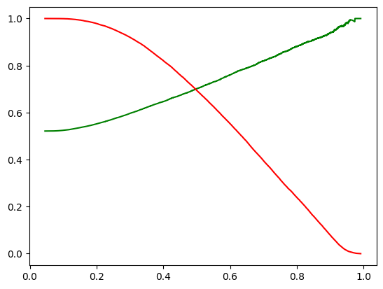

**Based on the above information, we decided to take 0.5 as cutoff.**

**Evaluation Matrix –**

* Accuracy - 0.6842999386532018
* True Positive - 7652
* True Negative - 6849
* False Positive - 3313
* False Negative - 3377
* Sensitivity - 0.6938072354701242
* Specificity - 0.6739814997047825
* Precision - 0.6978568171454629
* Recall - 0.6938072354701242

**Conclusion –**

From this exercise we conclude below parameters are important for employee retention -

- Years at Company

- Number of Promotions

- Overtime

- Distance from Home

- Number of Dependents

- Work-Life Balance_Fair

- Work-Life Balance_Poor

- Job Satisfaction_Low

- Job Satisfaction_Very High

- Performance Rating_Below Average

- Performance Rating_Low

- Education Level_PhD

- Job Level_Mid

- Job Level_Senior

Few factors need to consider as -

- Give more incentives or benefits to the employees worked more years, or they are doing overtime

- Also need to investigate on why employees are doing overtime and work life balance is poor and job satisfaction is low

- Add some travel facilities for employees commute from long distance

- Also need to think on improving employee’s performance rating. Check training needs and other support to do the best in work

- Employees like to grow on laddering so refresh hierarchical pyramid periodically

- Involve PhD employees in to the research and development programming to take advantage of their deep specialization